|  |  |
| --- | --- |
| Name: Hassan Bin Majid | EE-272L Digital Systems Design |
| Reg. No.: 2023-EE-019 | Marks Obtained: |

**Lab Manual**

|  |  |  |  |  |  |
| --- | --- | --- | --- | --- | --- |
| **DSD Lab Manual Evaluation Rubrics** | | | | | |
|  | | | | | |
| **Assessment** | **Total**  **Marks** | **Marks**  **Obtained** | **0-30%** | **30-60%** | **70-100%** |
| Code  Organization (CLO1) | 3 |  | No Proper Indentation and descriptive naming, no code organization.  Zero to Some understanding but not working | Proper Indentation or descriptive naming or code organization.  Mild to Complete understanding but not working | Proper Indentation and descriptive naming, code organization.  Complete understanding, and proper working |
| Simulation (CLO2) | 5 |  | Simulation not done or incorrect, without any understanding of waveforms | Working simulation with errors, don't cares's(x) and high impedance(z),  partial  understanding of waveforms | Working simulation without any errors, etc and complete understanding of waveforms |
| FPGA (CLO2) | 2 |  | Not implemented on FPGA and questions related to synthesis and  implementation not answered. | Correctly  Implemented on  FPGA or questions related to synthesis and  implementation  answered. | Correctly  Implemented on  FPGA and questions related to synthesis and  implementation  answered. |

**Schematic Diagram:**

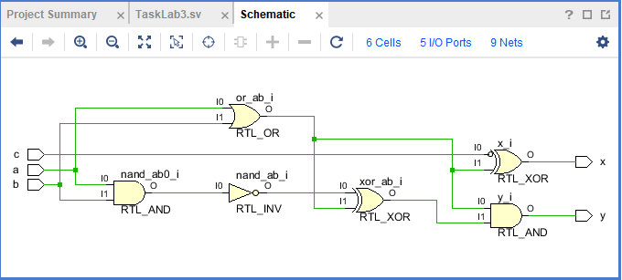

Task 1:

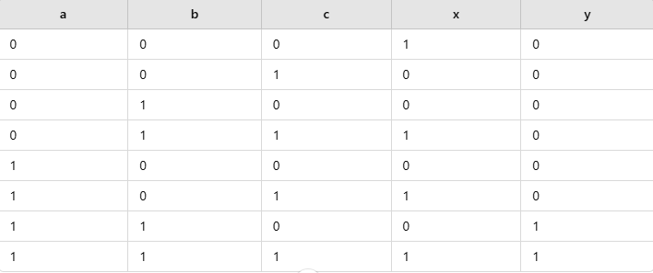

# Task 2:

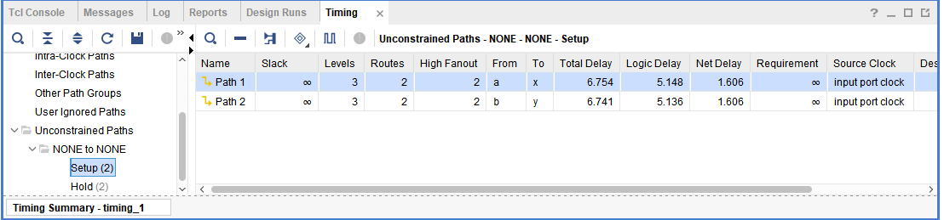

The path from a to x have maximum combinational delay.

# Task 3:

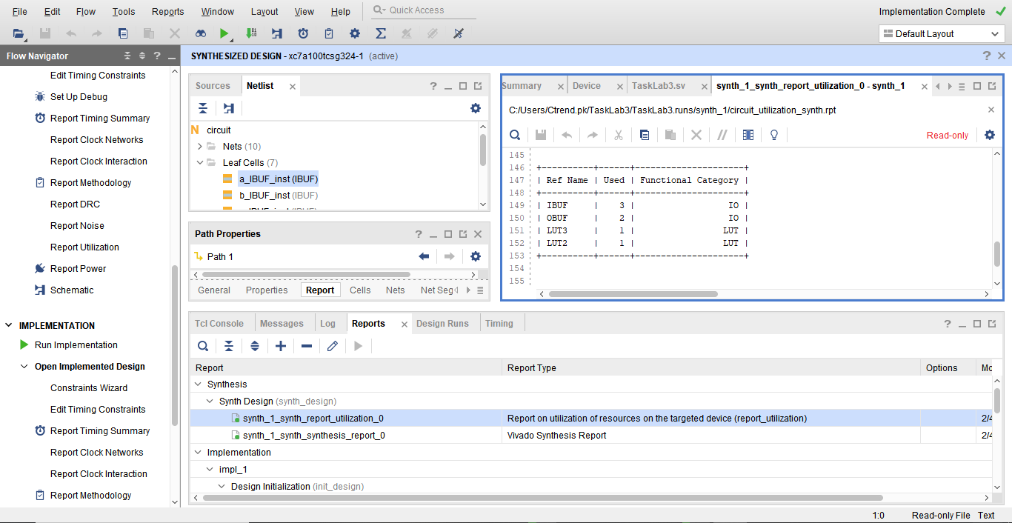

**2. System Verilog code for the circuit:**

